AI LAB

assisment-14.5

2503A52l17

Lab 14: Web Design Application – AI-Assisted HTML/CSS/JS  
Generation  
Lab Objectives  
• Design functional, visually appealing web applications using  
HTML, CSS, and JavaScript with AI assistance.  
• Apply responsive, accessible, and interactive design  
Week 7 -  
Friday

principles.  
• Create practical UI components for real-world web applications.  
• Use AI to optimize layout, UX, and performance

Task 1: AI-Assisted Portfolio Website  
Scenario:  
A student wants to showcase their projects, skills, and contact details in  
a portfolio website. Instead of writing all code manually, they want to  
speed up the process using GitHub Copilot.  
• Use Copilot to generate an HTML structure for a personal  
portfolio page (sections: Home, About, Projects, Contact).  
• Ask Copilot to suggest responsive CSS styling for the layout  
(e.g., grid/flexbox).  
• Customize Copilot’s suggestions to add a hover effect on project  
cards

HTML FILE FOR THE PRO GRAM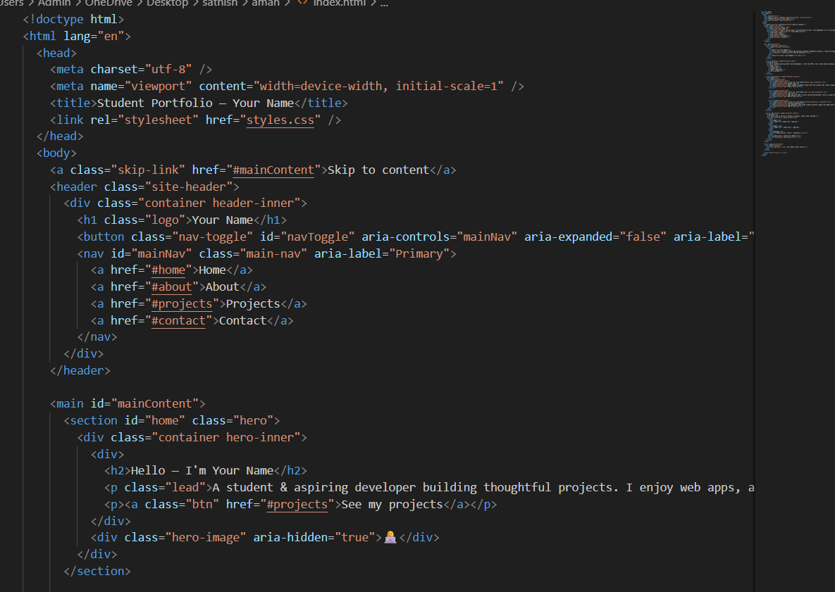

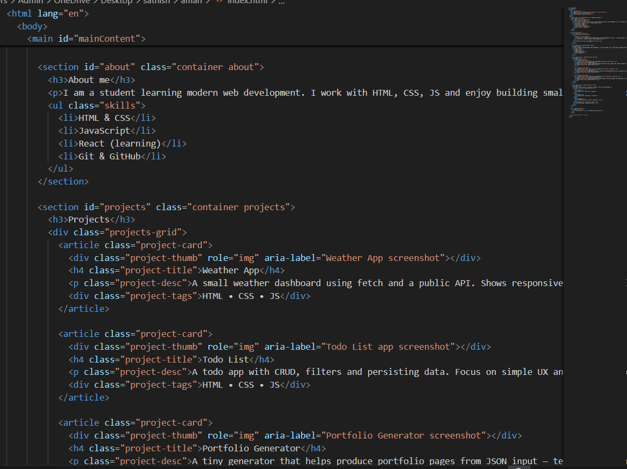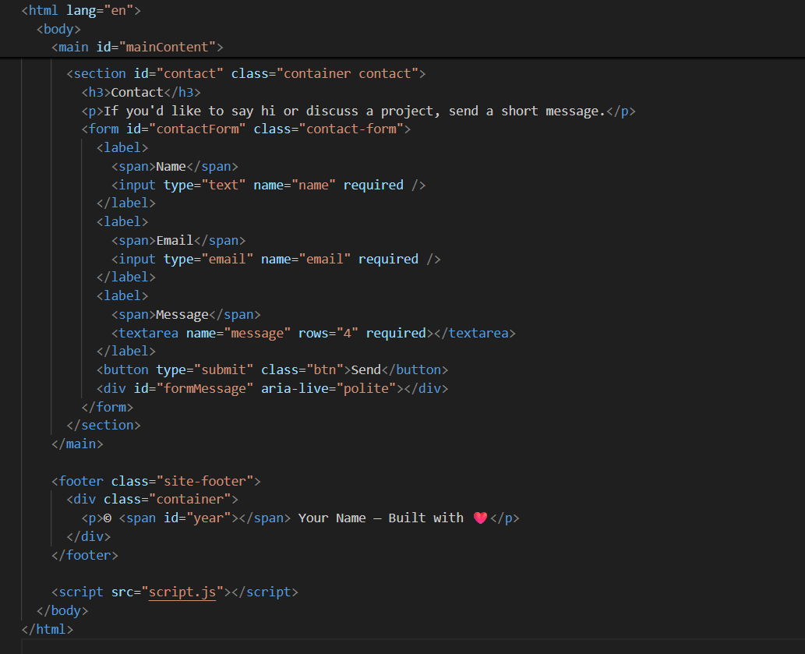

NOW IAM ADDING  
CSS AND JAVA SCRIPT STYLESHEETS

First css file

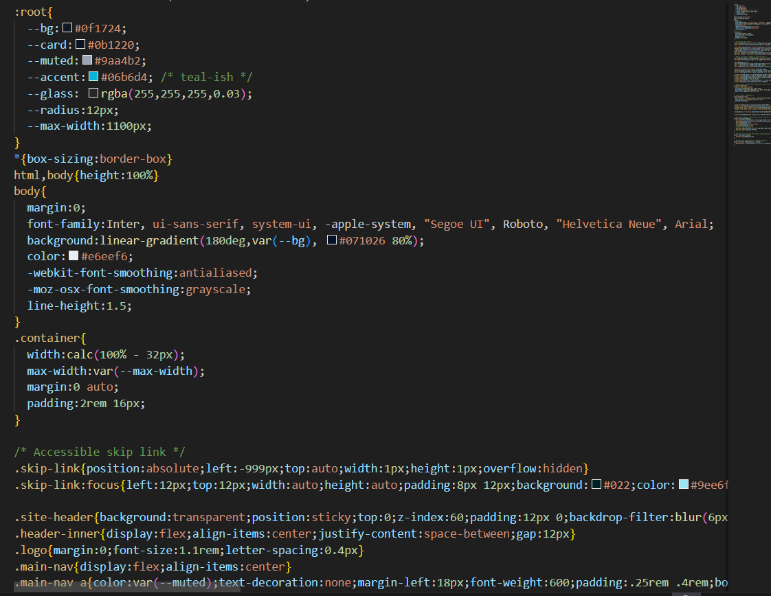

Second page of the css file

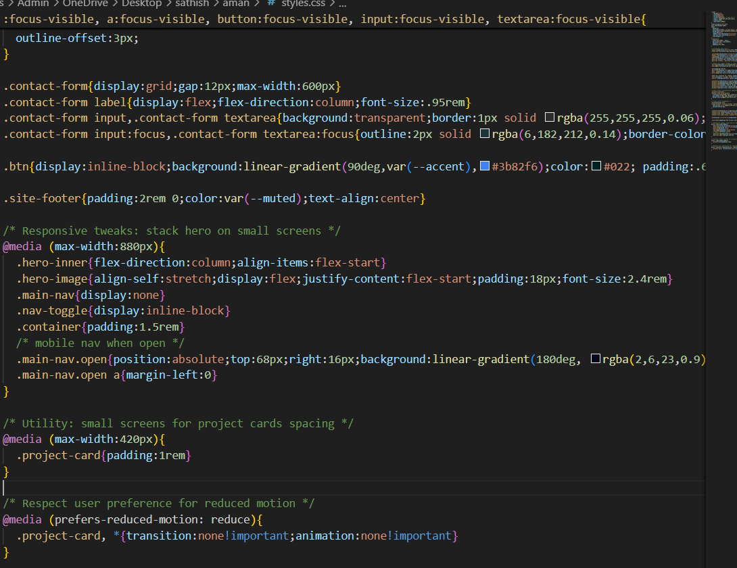

NOW java script files  
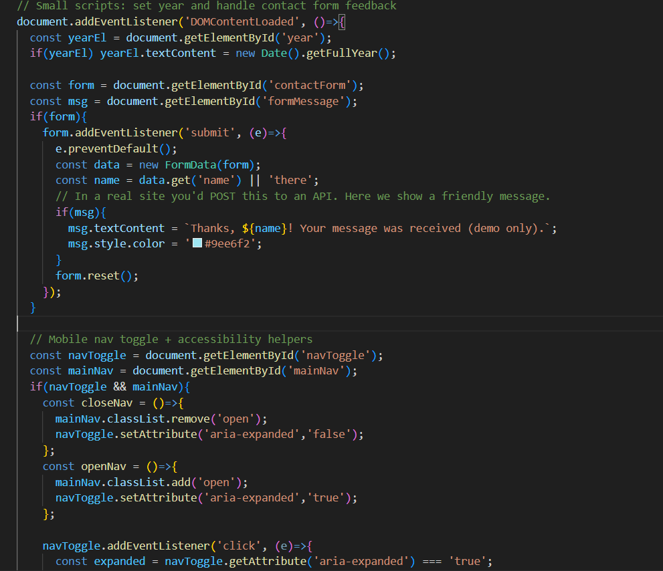

Second page of JS

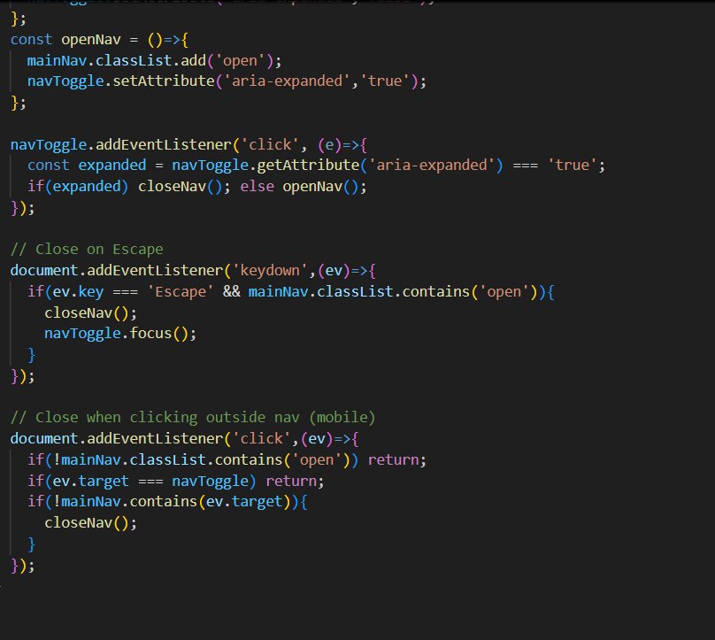

I have completed my task using the above codes  
link:file:///C:/Users/Admin/OneDrive/Desktop/sathish/aman/index.html

Task 2: AI-Generated Restaurant Landing Page  
Scenario:  
A local restaurant needs a simple landing page with a navigation bar,  
menu highlights, and an image gallery. The developer wants to quickly  
generate it using AI assistance.  
• Use Copilot to create a navigation bar with links (Home, Menu,  
Gallery, Contact).  
• Generate a menu section styled with CSS cards.  
• Add a JavaScript-based image slider for the gallery, with  
Copilot suggesting the base code

HTML CODE OF RESTUARENT  
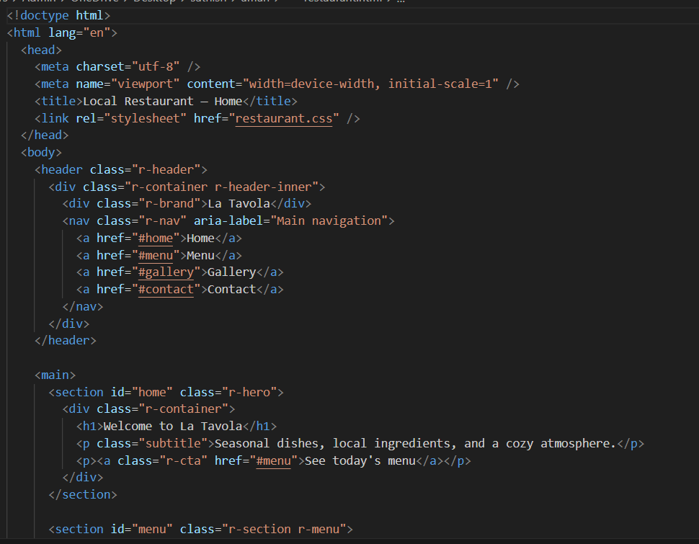

Second page of html code  
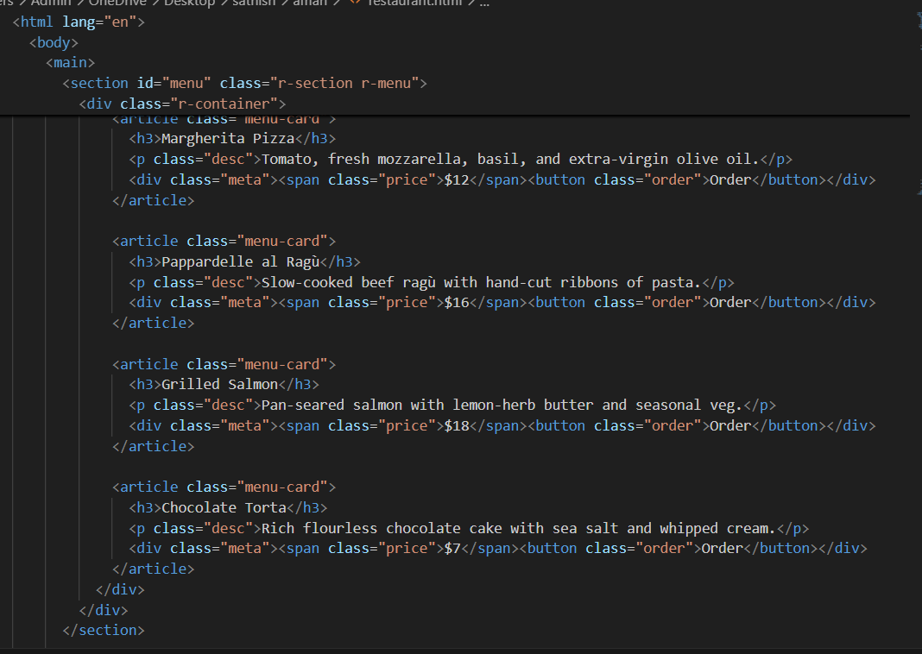

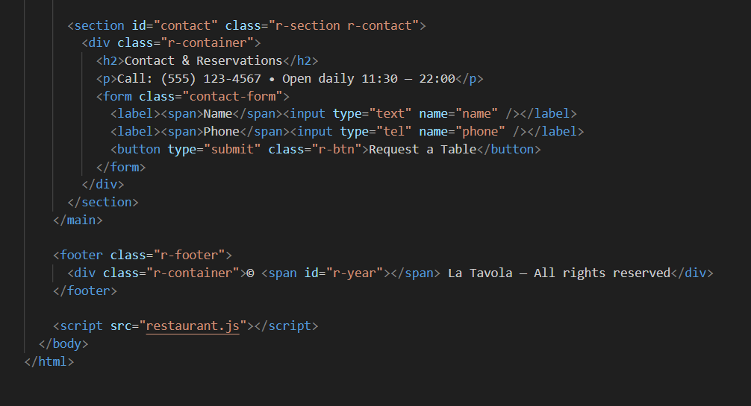

THE HTML CODE WAS COMPLETED  
NOW IAM ADDING CSS STYLING TO THE HTML CODE  
  
  
  
  
  
  
CSS CODE OF RESTUARENT  
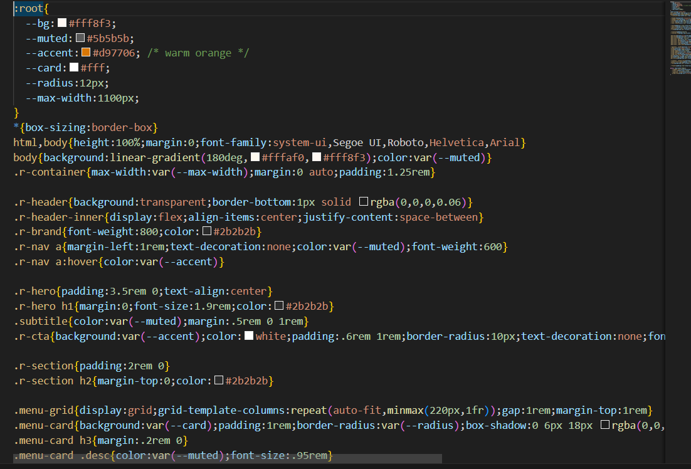

SECOND PAGE OF CSS CODE  
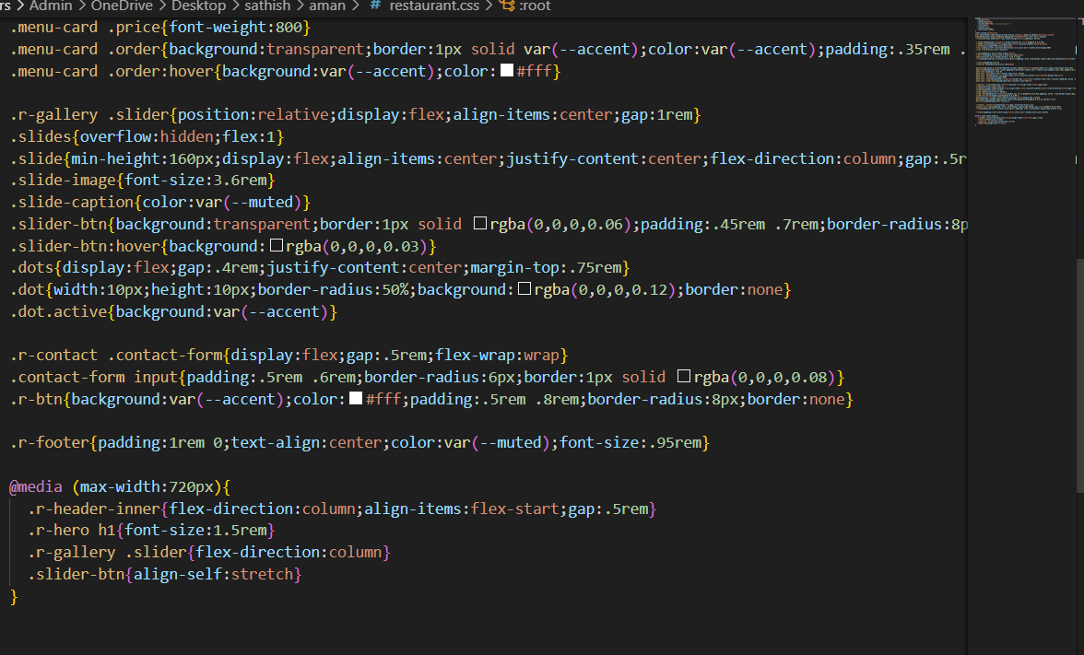

JAVA SCRIPT CODE OF THE RESTUARENT  
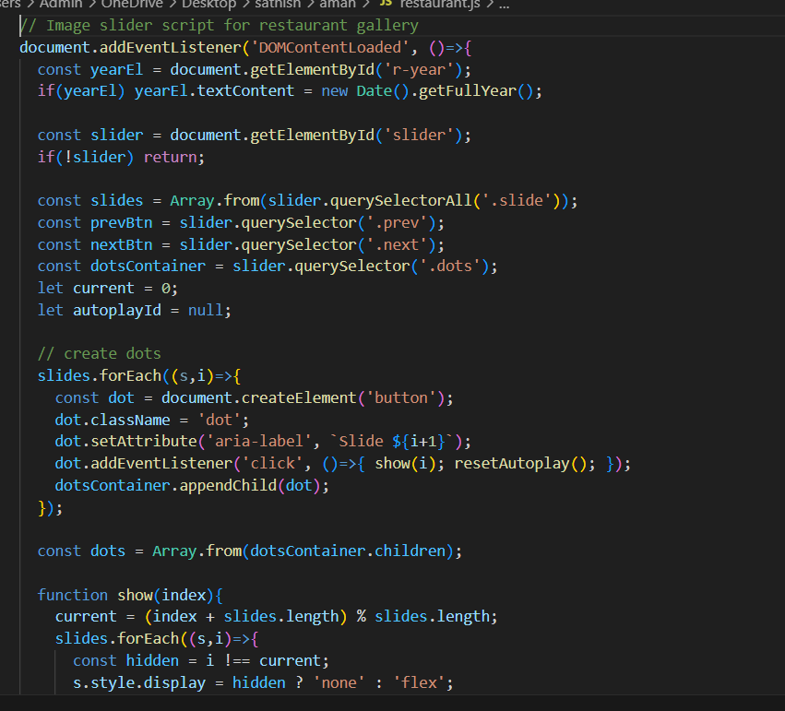

SECOND PAGE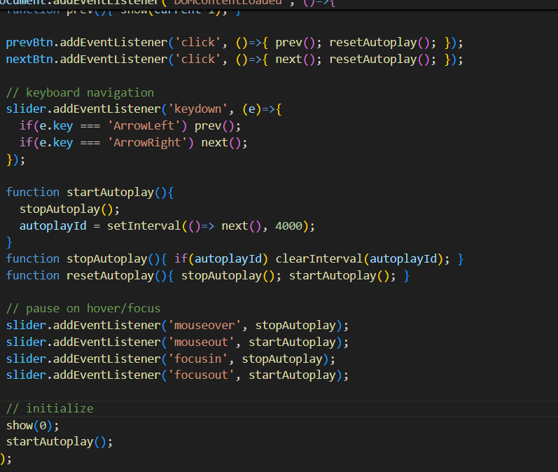

Task 3: AI-Powered Event Registration Form  
Scenario:  
SR University is hosting a tech fest. They need a web-based registration  
form for students. The form must validate user input in real-time.  
• Ask Copilot to generate an HTML form (fields: Name, Email,  
Phone, Department, Event Selection).  
• Use Copilot to assist in adding CSS styling for an attractive form  
layout.  
• Implement JavaScript validation (e.g., email format check,  
phone number length check) using Copilot’s suggestions   
  
  
HTML CODE OF THE SR UNIVERSITY  
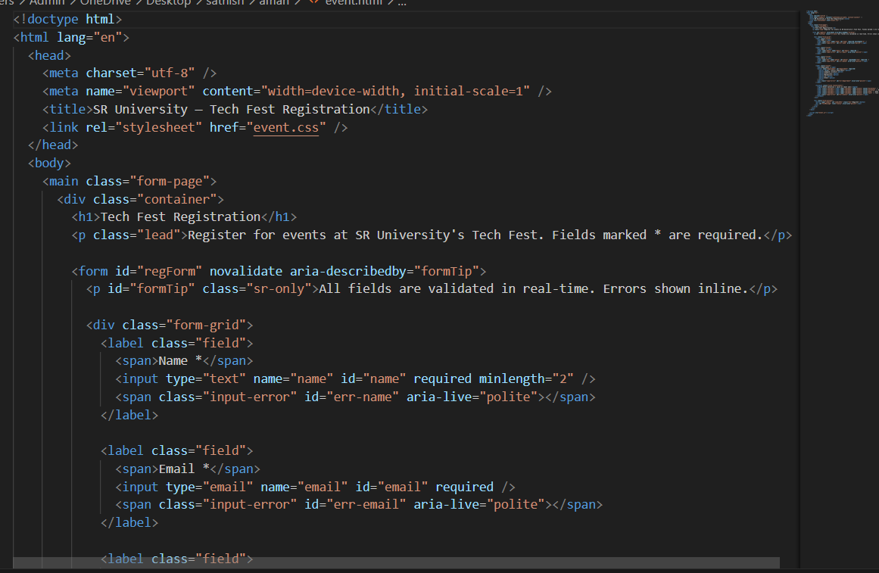

SECOND PAGE OF HTML CODE   
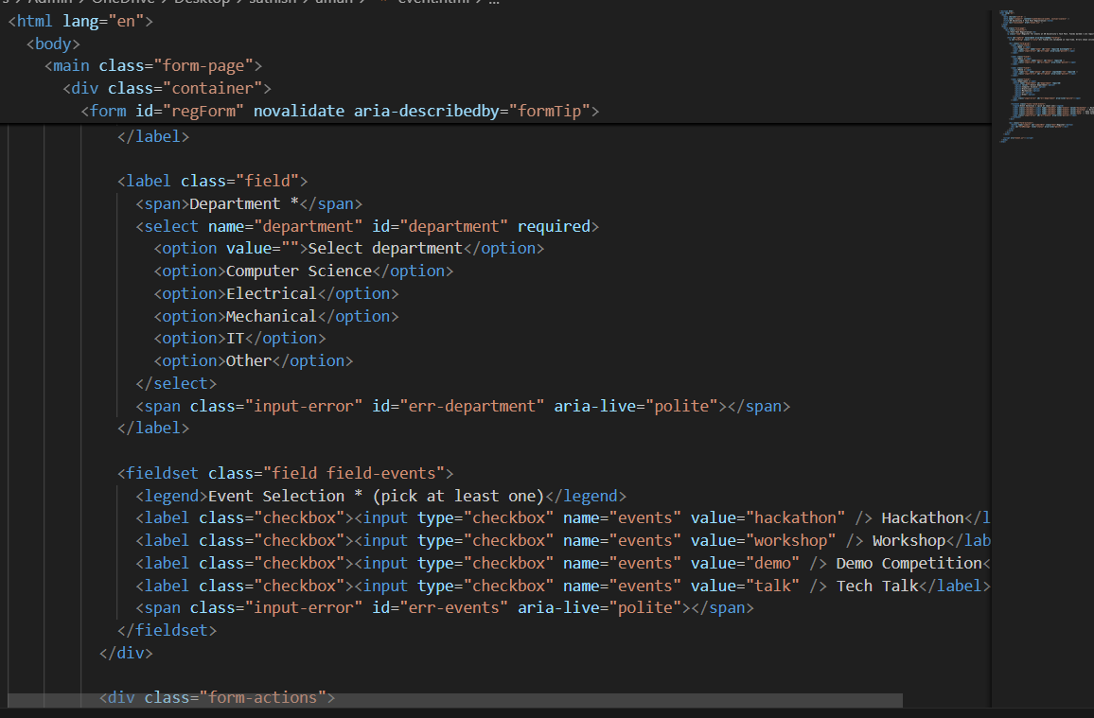

THIRD PAGE:OF HTML CODE  
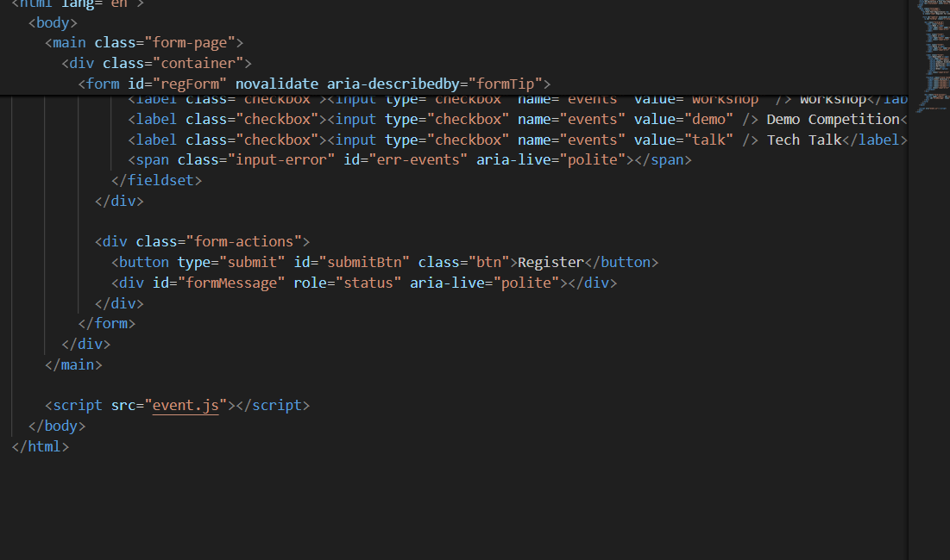  
  
CSS CODE OF THE SR UNIVERSITY  
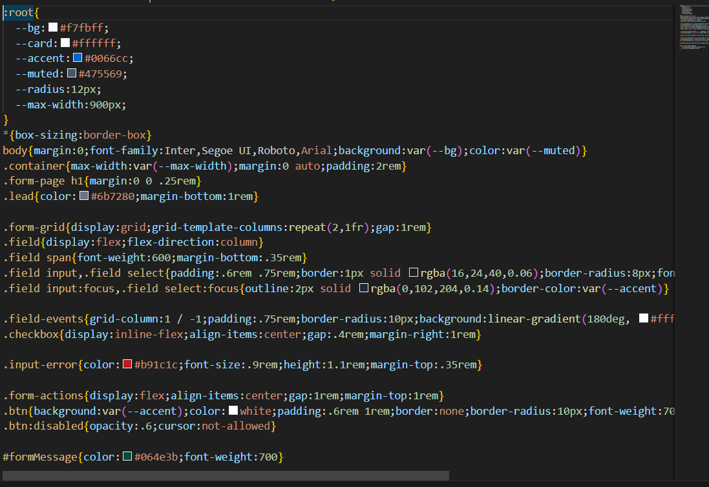

JAVA SCRIPT CODE OF THE PROGRAM  
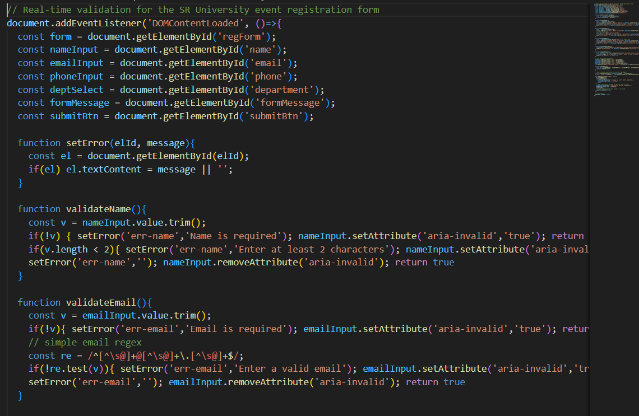

JAVA SCRIPT CODE OF THE PROGRAM  
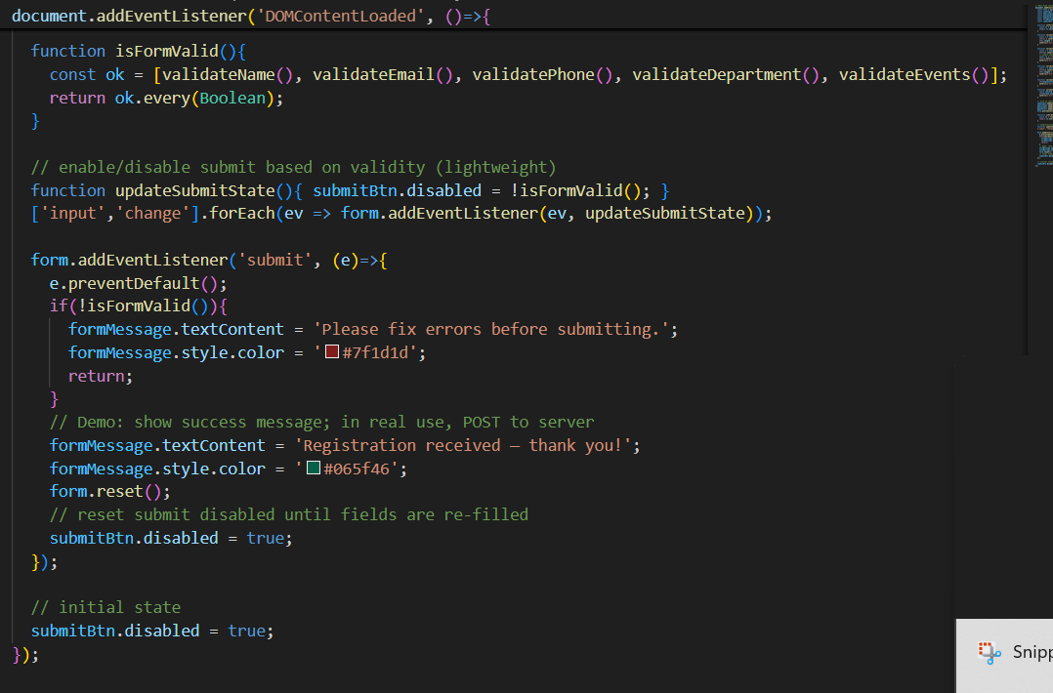

LINK:"C:\Users\Admin\OneDrive\Desktop\sathish\aman\event.html"

Task 4: AI-Assisted E-Commerce Product Page  
Scenario:  
A startup wants a basic e-commerce product page to display products  
with prices and an “Add to Cart” button.  
• Use Copilot to generate a grid-based product catalog in  
HTML/CSS.  
• Implement a JavaScript “Add to Cart” functionality with  
Copilot’s guidance.  
• Modify Copilot’s suggestions to include a cart counter at the  
top-right corner of the page

HTML CODE OF ECCOMMERCE STARTUP COMPANY WEBSITE

FIRST PAGE OF HTML  
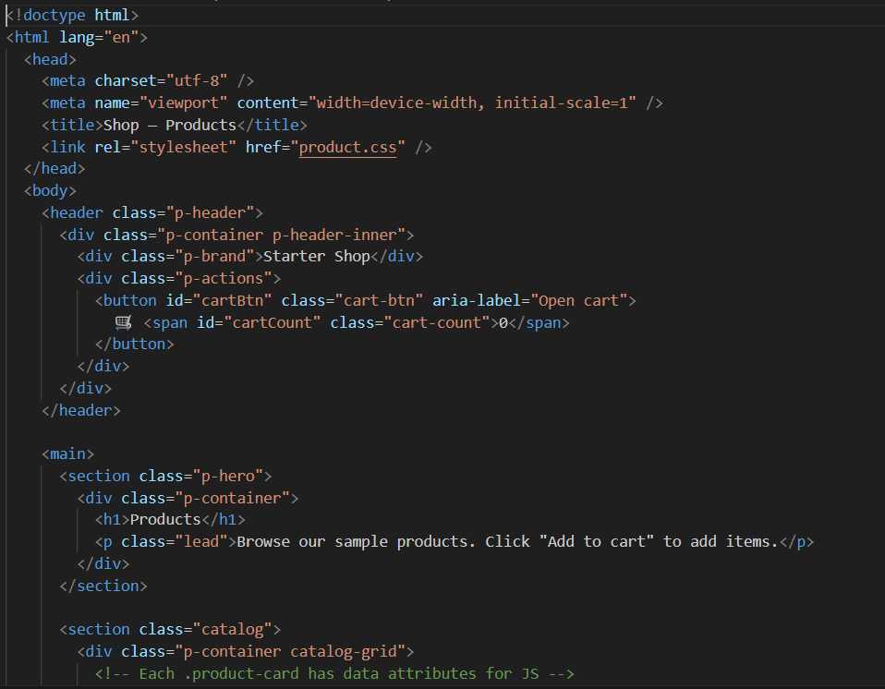

SECOND PAGE OF THE HTML CODE

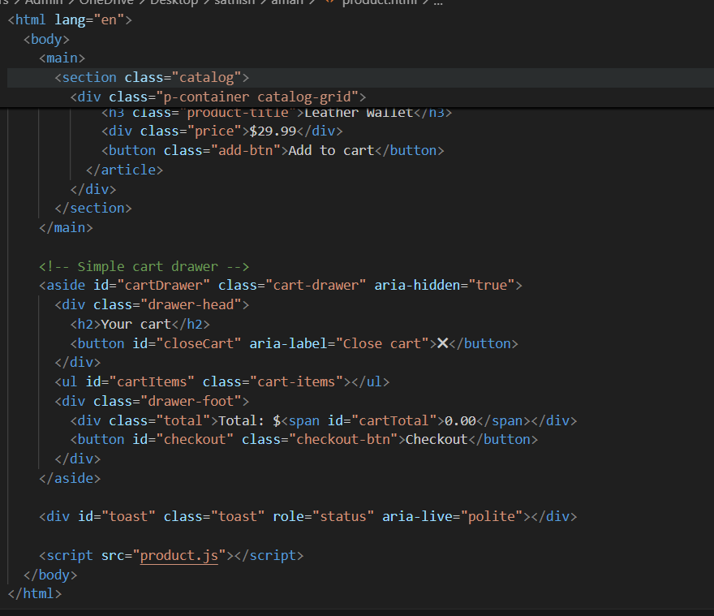

NOW IAM ADDING CSS STYLE TO THE HTML FILE OF THE PRODUCT  
  
CSS CODE:

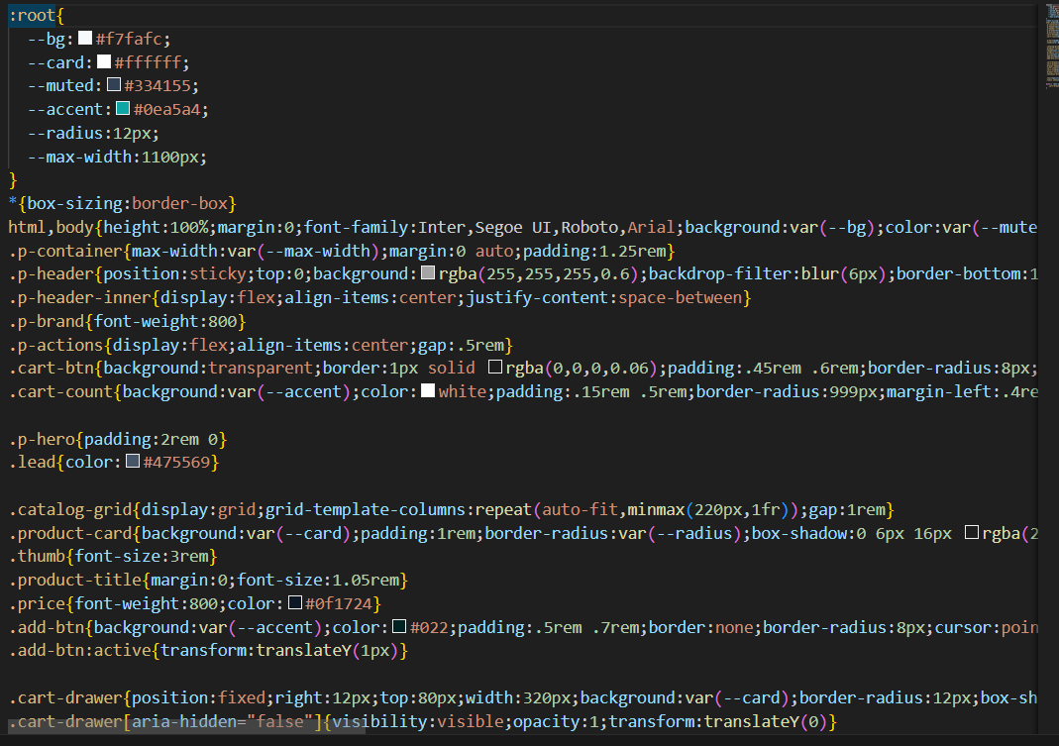

SECOND PAGE OF THE CSS CODE  
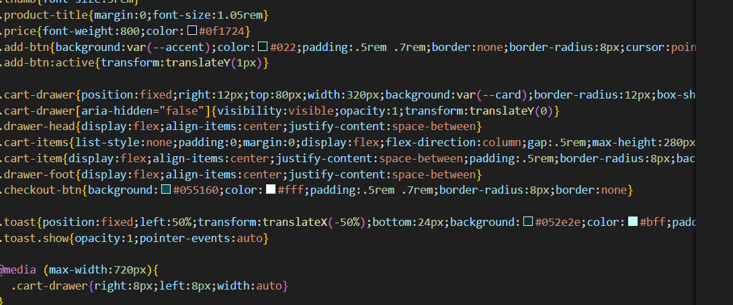

JAVASCRIPT CODE: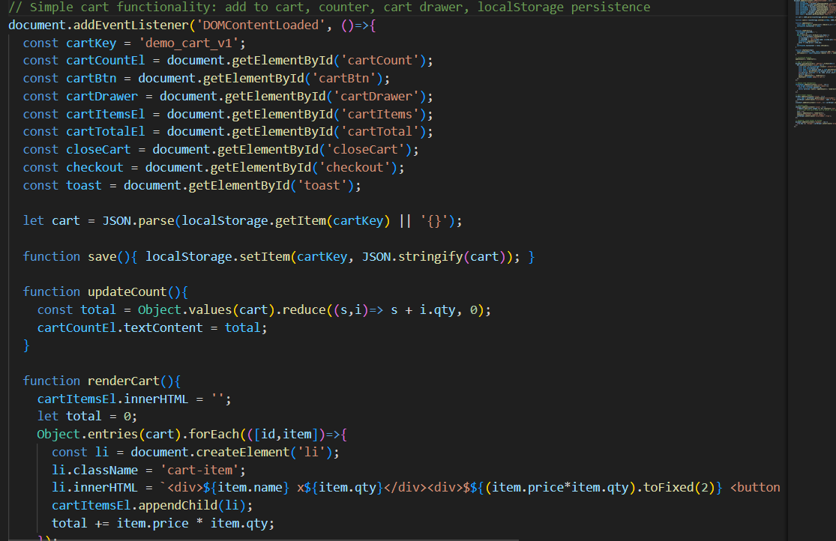

SECOND PAGE CODE   
